Chapter 18, Solution 27.

(a) Let 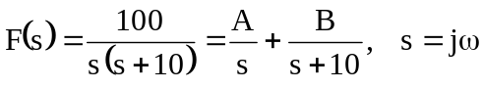
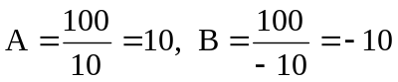
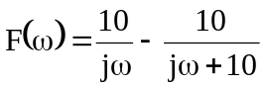
f(t) = 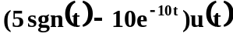

- 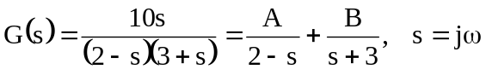
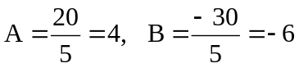
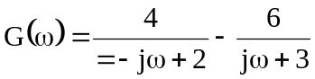
g(t) = 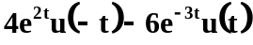
- 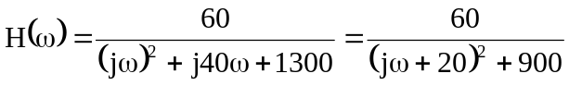
h(t) = 
 